Michael Weaver

CST – 221

John Zupan

1/28/2018

GitHub Link: https://github.com/battousairurik/CST-221

**Producer and Consumer Assignment**

Approach

The producer thread calls a produce method which generates a random number and places it into the buffer via the put function. The put function causes the thread to sleep if the buffer is full and generates a wake-up call to the consumer thread.

The consumer thread calls a get function to retrieve the stored element in the buffer and sets the thread to sleep if the buffer is empty. Once the element has been retrieved the buffer is reset to 0 and the consume function is called to print the randomly generated number to the screen. Finally, the get function wakes up the producer thread to continue number generation.

Screenshot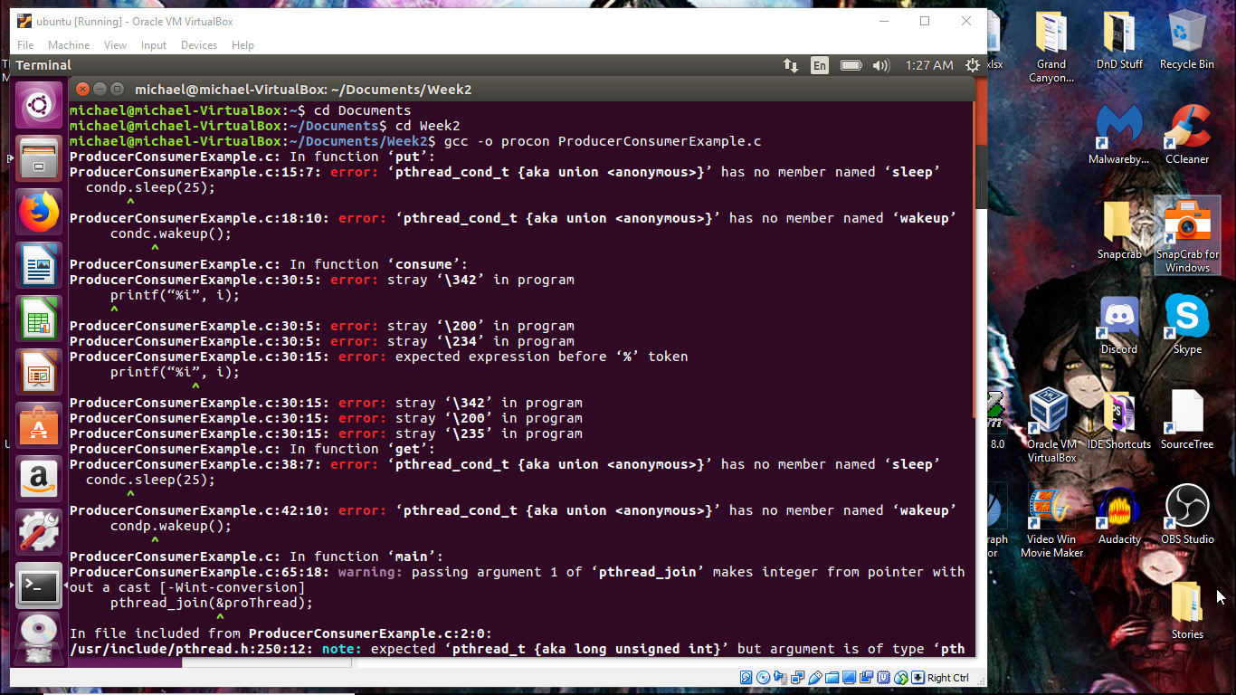

Without using some form of synchronization mechanism, I have no idea how to solve this problem. Even then, I tested one which uses mutex and locking mechanism, though it doesn’t execute properly either. The screenshot of the alternate program is included, though it isn’t one I coded myself, its an example that I used to build my attempt.

I cannot generate an output text file because I cannot get the program to actually execute. Please provide me with instructions on how to fix this so I do not fail this class.

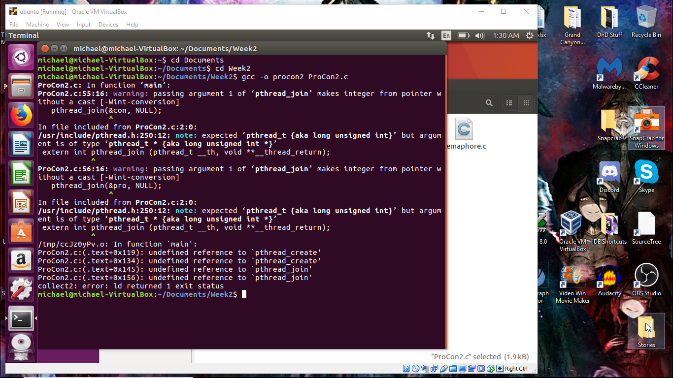

References

Temple.edu. (N.D.). *Threads: Implementing Monitors using locks and condition variables*. Retrieved from https://cis.temple.edu/~giorgio/old/cis307s96/readings/pbuffer.html

Tanenbaum. (2014). *Solution to producer consumer problem.* Retrieved from https://www.google.com/url?sa=t&rct=j&q=&esrc=s&source=web&cd=5&cad=rja&uact=8&ved=0ahUKEwje3ISZqPzYAhXJq1MKHTxAASIQFgg_MAQ&url=http%3A%2F%2Fcis.poly.edu%2Fcs3224a%2FCode%2FProducerConsumerUsingPthreads.c&usg=AOvVaw2AdefqxVbAUO1oDtnD_xrM

The CrazyProgrammer. (2017). *Producer Consumer Problem in C.* Retrieved from https://www.thecrazyprogrammer.com/2016/09/producer-consumer-problem-c.html

Tim. (2010). *Pthreads in C – a minimal working example.* Retrieved from http://timmurphy.org/2010/05/04/pthreads-in-c-a-minimal-working-example/